Supplementary Materials
Table 1 RMSE
Scene | SpAGAN | SpAGAN+RL |  | ACA-CRNet | ACA-CRNet+RL
S1 | 0.0428 | 0.0343 | 0.0134 |  | 0.0138
S2 | 0.0659 | 0.0278 | 0.0129 |  | 0.0116
S3 | 0.0253 | 0.0337 | 0.0095 |  | 0.0099
S4 | 0.0791 | 0.0454 | 0.0296 |  | 0.0215
S5 | 0.0371 | 0.0303 | 0.0175 |  | 0.0170
S6 | 0.1796 | 0.0379 | 0.0287 |  | 0.0218
S7 | 0.0458 | 0.0384 | 0.0234 |  | 0.0233
S8 | 0.0596 | 0.0493 | 0.0293 |  | 0.0295
S9 | 0.1399 | 0.0471 | 0.0438 |  | 0.0259
S10 | 0.0713 | 0.0477 | 0.0307 |  | 0.0275
Average Ranking | 3.9/4 | 3.1/4 | 1.7/4 |  | 1.3/4

Table 2 SSIM
scene | SpAGAN | SpAGAN+RL |  | ACA-CRNet | ACA-CRNet+RL
S1 | 0.9755 | 0.9856 | 0.9919 |  | 0.9917
S2 | 0.9499 | 0.9854 | 0.9910 |  | 0.9920
S3 | 0.9798 | 0.9832 | 0.9923 |  | 0.9915
S4 | 0.9363 | 0.9805 | 0.9829 |  | 0.9861
S5 | 0.9773 | 0.9855 | 0.9907 |  | 0.9902
S6 | 0.7674 | 0.9802 | 0.9827 |  | 0.9881
S7 | 0.9711 | 0.9819 | 0.9868 |  | 0.9885
S8 | 0.9572 | 0.9789 | 0.9838 |  | 0.9847
S9 | 0.8789 | 0.9797 | 0.9788 |  | 0.9865
S10 | 0.9492 | 0.9797 | 0.9850 |  | 0.9866
Average ranking | 4/4 | 2.9/4 | 1.8/4 |  | 1.3/4
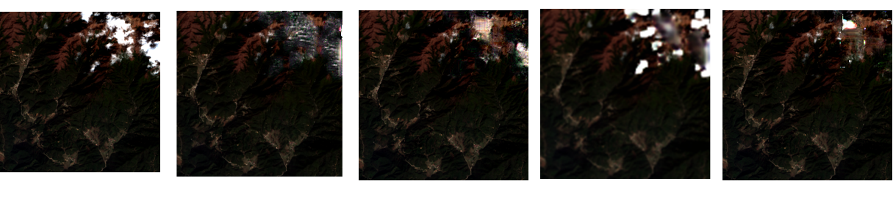
ACA-CRNet+RL
Original
SpAGAN
SpAGAN+RL
ACA-CRNet
Figure 1 Performance on real scene
Table 3 Running Time
 | SpAGAN | SpAGAN+RL | ACA-CRNet | ACA-CRNet+RL
Time (second) | 0.273 | 2.097 | 0.337 | 4.756

